
AfterCodecs is a new native exporter for Adobe After Effects, Premiere Pro and Media Encoder CC 2015+ on Windows 7+ and Mac OS X 10.10+, bringing you ffmpeg's ProRes, H264, H265 & Hap for excellent quality and lightweight videos

Installation

You can skip step 1 and 3 with the given setup .exe
You can also skip the two first steps by using the aescripts + aeplugins manager application

- Close all running instances of AE, PPro and AME !
- Copy the AfterCodecsAE_Win.aex and AfterCodecsPPME_Win.prm into the Plug-ins folder of your Common plug-ins :
C:\Program Files\Adobe\Common\Plug-ins\7.0\MediaCore
- Now you have to license the plugins in the AfterCodecs Settings :
  - Open After Effects or Premiere Pro or Media Encoder
  - In After Effects you can go directly to Composition -> AfterCodecs Settings
  - In any case you can go to AfterCodecs Settings by trying to export something.
In AE :
    - Open a project, click the menu Composition -> Add to Render Queue
    - In the Render Queue window, in your item to render click the arrow to open the Output Module Settings
    - In the Format dropdown, choose "AfterCodecs .mov" or "AfterCodecs.mp4" then click the "Format Options" button. You're in AfterCodecs ! You will choose your codec options here later
    - Go to the Settings tab and enter your license in the textarea and press the "Activate license" button
  - In AME it's the same as in PPro but you need to click on the render queue item's Format or Settings blue-highlighted string
  - In PPro :
    - Open a project, open a sequence to render, click its timeline window
    - CTRL+M or Export -> Media...
    - In the Format dropdown (top right of the popup) select "AfterCodecs". Here you can choose some options related to the PPro / AME export.
    - Click the "Open AfterCodecs Settings". You're in AfterCodecs ! You will choose your codec options here later
    - Go to the Settings tab and enter your license in the textarea and press the "Activate license" button
- In the same tab whre you licensed AfterCodecs, if there's a red colored string indicating you don't have the ffmpeg / ffkroma binaries, you will need to download them : just press the "Download / Update" button and wait for the download to finish. It will create this folder : %appdata%/Autokroma/ffmpeg
and extract ffmpeg and ffkroma binaries into it. You can also do this manually (if you encountered the "invalid zip file" error) by downloading the zip at the bottom of this page http://aescripts.com/aftercodecs/ and extracting the files and creating the folder on your own. This should look like this at the end :
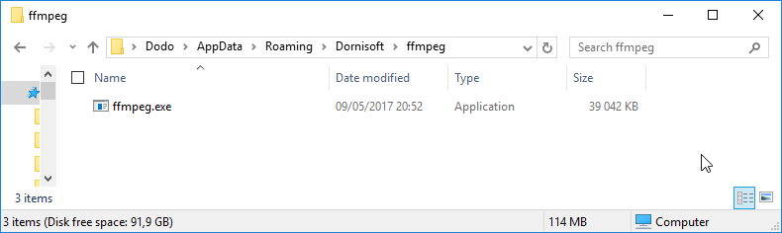

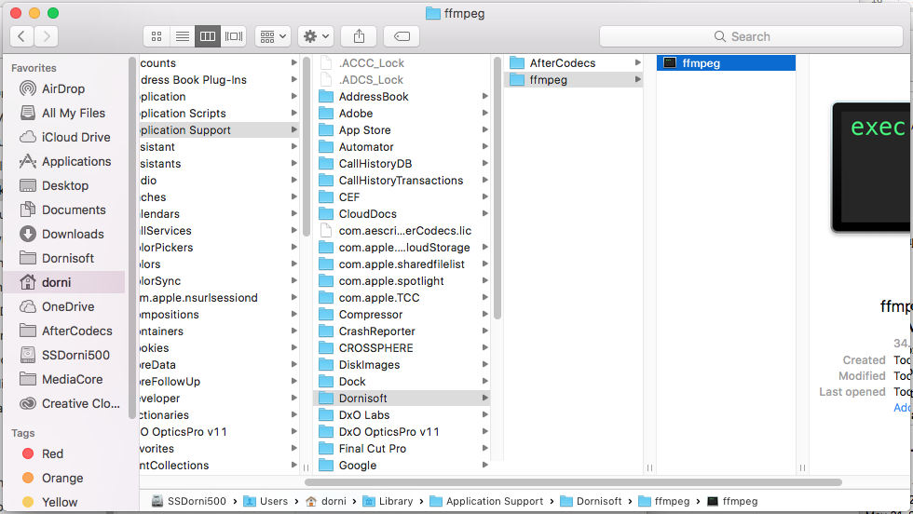

How AfterCodecs works

AfterCodecs pipes your data into ffmpeg in order to encode it.
The logging feature enables power users to read AfterCodecs' and ffmpeg's output logs.

On AE : If you have both video and audio, temporary files will be written (suffixed .video.mov and .audio.wav) and there is an additional muxing step at the end of the render (a progressbar will pop up on Windows). Please bear in mind that After Effects will prevent you from overwriting the final output file, but not temporary ones. You can even stop the render at any time and the rendered files will be fine, storing what has been currently rendered.

On PP / ME : If you have audio, a temporary WAV file will be written (suffixed .audio.wav). Please bear in mind that AfterCodecs will not prevent you from overwriting temporary files.

PP /ME : Extensions : MP4, MOV (QuickTime), EXT
Select the EXT extension to save up time if you are doing huge renders (multi gigabytes) or if you want to remove the "File already exists. Do you want to replace it." confirmation popup. This option is not compatible with having post render actions such as automatic uploading to the web. The reason this option exists is that on huge files, PP and ME will spend multiple minutes to parse the file (make the test to see if it's an issue for you !)

PP /ME : Match Source + Preset
Don't forget to press the "Match Source" button in order to conform Resolution, Framerate and Pixel Aspect Ratio to the source (the button will automatically tick the checkboxes at the right). If you record any preset also press the Match Source button before so that you are sure you are not saving thoses parameters in the preset.

Feedback
If you need a specific feature or have any kind of feedback, please fill out this form : https://goo.gl/forms/PqykHc3pXQYylqIa2 . For any issue please contact us on aescripts + aeplugins by opening up a ticket and provide a logging file and precising AE or PP/ME http://aescripts.com/contact/?direct=1&SKU=DSTAC-SUL .

Thank you for purchasing and using AfterCodecs !

